Microservices Architecture using ASP.NET Core Web API
- (Superset ID - 6363141) Debasish Bisoi

1. Implement JWT Authentication in ASP.NET Core Web API
Code –
Filename – Appsettings.json
{
"Jwt": {
"Key": "ThisIsASecureKeyForJwtToken@2025##@@@",
"Issuer": "MyAuthServer",
"Audience": "MyApiUsers",
"DurationInMinutes": 60
},
"Logging": {
"LogLevel": {
"Default": "Information",
"Microsoft.AspNetCore": "Warning"
}
},
"AllowedHosts": "*"
}
LoginModel.cs
namespace JwtAuthDemo.Models
{
public class LoginModel
{
public required string Username { get; set; }
public required string Password { get; set; }
}
}

Program.cs
using Microsoft.AspNetCore.Authentication.JwtBearer;
using Microsoft.IdentityModel.Tokens;
using System.Text;
var builder = WebApplication.CreateBuilder(args);
builder.Services.AddControllers();
builder.Services.AddEndpointsApiExplorer();
builder.Services.AddSwaggerGen();

builder.Services.AddAuthentication("Bearer")
.AddJwtBearer("Bearer", options =>
{
options.TokenValidationParameters = new TokenValidationParameters
{
ValidateIssuer = true,
ValidateAudience = true,
ValidateLifetime = true,
ValidateIssuerSigningKey = true,
ValidIssuer = builder.Configuration["Jwt:Issuer"],
ValidAudience = builder.Configuration["Jwt:Audience"],
IssuerSigningKey = new SymmetricSecurityKey(
Encoding.UTF8.GetBytes(builder.Configuration["Jwt:Key"]))
};
});

builder.Services.AddAuthorization();

var app = builder.Build();

app.UseHttpsRedirection();

if (app.Environment.IsDevelopment())
{
app.UseSwagger();
app.UseSwaggerUI();
}

app.UseAuthentication();
app.UseAuthorization();
app.MapControllers();
app.Run();
AuthController.cs
using JwtAuthDemo.Models;
using Microsoft.AspNetCore.Mvc;
using Microsoft.IdentityModel.Tokens;
using System.IdentityModel.Tokens.Jwt;
using System.Security.Claims;
using System.Text;

namespace JwtAuthDemo.Controllers
{
[ApiController]
[Route("api/[controller]")]
public class AuthController : ControllerBase
{
private readonly IConfiguration _configuration;

public AuthController(IConfiguration configuration)
{
_configuration = configuration;
}

[HttpPost("login")]
public IActionResult Login([FromBody] LoginModel model)
{
if (IsValidUser(model))
{
var token = GenerateJwtToken(model.Username);
return Ok(new { Token = token });
}

return Unauthorized();
}

private bool IsValidUser(LoginModel model)
{
return model.Username == "admin" && model.Password == "password";
}

private string GenerateJwtToken(string username)
{
var claims = new[]
{
new Claim(ClaimTypes.Name, username)
};
var key = new SymmetricSecurityKey(Encoding.UTF8.GetBytes(_configuration["Jwt:Key"]));
var creds = new SigningCredentials(key, SecurityAlgorithms.HmacSha256);
var token = new JwtSecurityToken(
issuer: _configuration["Jwt:Issuer"],
audience: _configuration["Jwt:Audience"],
claims: claims,
expires: DateTime.Now.AddMinutes(60),
signingCredentials: creds);

return new JwtSecurityTokenHandler().WriteToken(token);
}
}
}
SecretController.cs
using Microsoft.AspNetCore.Authorization;
using Microsoft.AspNetCore.Mvc;

namespace JwtAuthDemo.Controllers
{
[ApiController]
[Route("api/[controller]")]
public class SecretController : ControllerBase
{
[Authorize]
[HttpGet]
public IActionResult GetSecret()
{
return Ok("You have accessed a protected endpoint!");
}
}
}

Output –
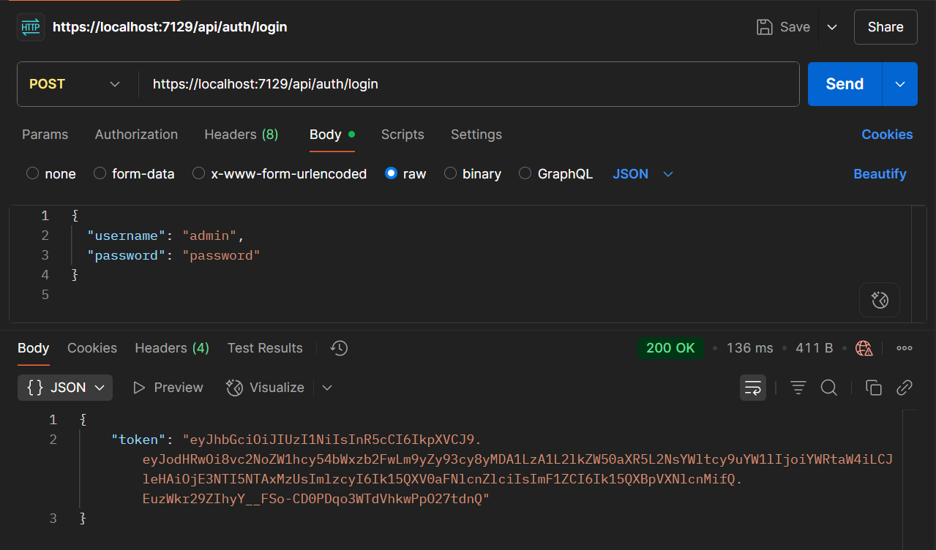
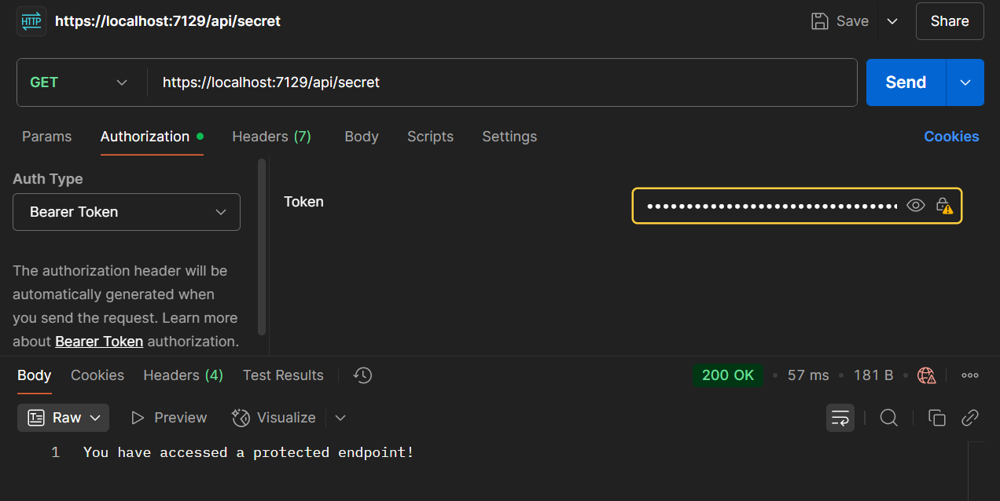
Name – Debasish Bisoi
Roll Number – 22052456
Superset ID - 6363141
College – Kalinga Institute of Industrial Technology (KIIT), Bhubaneswar

